|  |
| --- |
| **Surface Area of a Cylinder = 2 π r 2 + 2 π r h** |

http://www.math.com/tables/geometry/cylinder1.gif(h is the height of the cylinder, r is the radius of the top)

Surface Area = Areas of top and bottom +Area of the side

Surface Area = 2(Area of top & bottom) + (perimeter of top)* height

Surface Area = 2(**π** r 2) + (2 **π**r) • h so what if we look at this formula a little differently → 2 **π**r • r + 2 **π**r • h we can factor out 2 **π**r leaving r + h → (2 **π**r)(r+h) or we can say 2 **π**r(r+h)

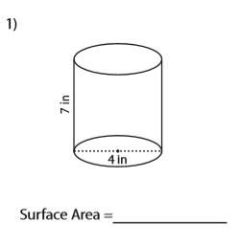Examples:

Our height h =7 π = 3.14 and we don’t have a radius r, we have a Diameter d = 4 which is twice as big as the radius. Take 4 divide by 2 and you get your radius of 2.

Our formula:

2πr (2+h) = total surface area

2 • 3.14 • 2 • (2 + 7)

6.28 • 2 • 9

113.04

12.56 • 9

25.12 + 175.84 = 113.04 in2

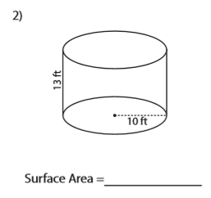Our height h =13 π = 3.14 and r = 10

Our formula:

2πr2 + 2πrh = total surface area

2 • 3.14 • 10 • (10 + 13)

62.8• 23 = 1444.4 ft2

1444.4 ft2